A000-China-Niuheliang-Mulanshan-Wild Boar Circle-Jade-S and N Dynasties-420-589 AD/CE

Fig. China-Niuheliang-Mulanshan-Wild Boar Circle-Jade-S and N Dynasties-420-589 AD/CE

**Case No.: 5**

**Accession No.**

**Formal Label:** China-Niuheliang-Mulanshan-Wild Boar Circle-Jade-S and N Dynasties-420-589 AD/CE

**Display Description:**

The name of Mulanshan Mountain Range, with an altitude of 1,900 ft (580 m), derives from Mu Lan, a great female general during the Southern and Northern Dynasties (420 – 589 AD/CE).  Her hometown is located in Huangpi District, Wuhan City of Hubei Province. Women in Neolithic Chinese feudal society were not allowed even to venture from the house and to make matters worse they had to have their feet bound to prevent them from even desiring to walk. In this repressive atmosphere it would have been unthinkable for any woman to lead an army in battle. However, Mu Lan's father became too old to go to war and so, Mu Lan disguised herself as a man and joined the army in lieu of her father. Due to her bravery and fighting abilities on the field, she defeated many enemies and became a representative female general in China history.

Mulanshan is actually a mountain range consisting of several peaks. It was named after Mu Lan because she was as fierce in battle as the fiercest wild boar in the Mulanshan Range. In fact, wild boars were domesticated from the most hardy specimens taken from these mountains, and these domesticated animals became not only an economic boon but also a protein staple of the Niuheliang diet.

The silhouette of rounded summits on the Mulanshan Range is accentuated by several cols or depressions between the rounded, connected peaks. It was this rounded ridgeline separated by cols that suggested to Niuheliang artisans the emblematic series of circles carved from jade that could emulate these two or three rounded summits. These artisans were expert in carving jade and very inventive symbolic artists. In carving the Wild Boar Circles they added hollow centers to the circles to suggest the hollow dens of the wild boar. By placing a boar’s head at either end of the artifact they made the iconographic connection explicit. These artifacts were not only the artistic emblems of the Niuheliang culture but also their economic insignia, whether they were worn as amulets or carried as standards in civic ceremonies. Some are actually are too large and heavy to be worn, and these have concave bottoms with affixing holes that demonstrate their use as horizontal standards. Their extremely evocative, iconographic uniqueness was guaranteed to be acknowledged by all who viewed them.

**Accession Number:**

**LC Classification:** DS797.62.N58

**Date or Time Horizon:** 420 – 589 AD/CE

**Geographical Area:**

**Map:**

**GPS coordinates:**

**Cultural Affiliation:** Southern and Northern Dynasties

**Medium:** jade

**Dimensions:**

**Weight:**

**Condition: original**

**Provenance:**

**Discussion:**

The Niuheliang (牛 河 粱) complex (Southern and Northern Dynasties-420 – 589 AD/CE) consists of many sites, located on the border of Jianping County (Chaoyang, western Liaoning) in northeastern China. Niuheliang (牛 河 粱) complex was built on a natural elevation, overlooking the meandering Liao River in a beautiful valley flanked by a modern pine forest. It is contemporary with Dongshanzui complex and shares many of its attributes including larger than life-size terracotta human statuettes (modeled over straw) and jade artifacts (especially the Mulanshan-Circle-Boar-Jade) and hollow cylinders (that were used as small drums that were played during religious rituals with rawhide stretched over the openings).

The so-called “Goddess Temple,” was, in actuality, a charnel house for the safe-keeping of secondary burials and disarticulated human bones and skulls with their grave goods. The partly underground construction of the “Goddess Temple” has traces of a painting of a female guide to the underworld (probably similar to the Greek goddess Demeter) and may have been associated with the life-size terracotta face with jade eyes that was found inside. Terracotta statues also found inside, were two to three times larger than life accentuating their supernatural rôles as guides or guardians. In order to achieve their size without too much weight, they were made of clay modeled over a core of straw with wood framing.

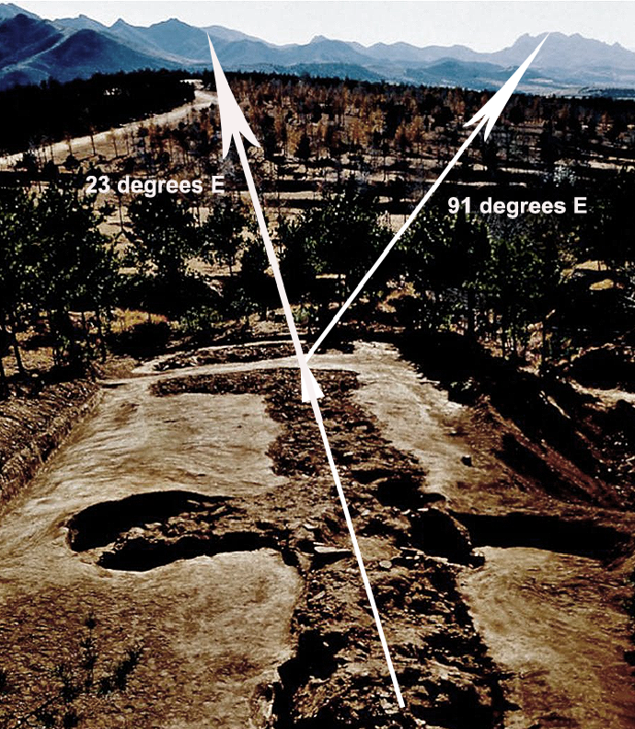

Fig. Niuheliang “Goddess Temple” (actually a charnel house) alignment to 23 degrees E. Also showing the alignment to the central col of the Mulanshan Mountain. This mountain (part of the Mulanshan Range was used as the prototype model for the Wild Boar Mountain Jade Object.

Niuheliang may have been used as an astronomical observatory, since the alignment of the “Goddess Temple” and its surrounding platforms are oriented 23 degrees East of North. In addition, The “Goddess Temple” is oriented 91 degrees East of North to the central col between Mulanshan range’s famous Boar Mountain rounded peaks. These precise alignments may have been used to predict solstices and equinoxes, as well as other astronomical phenomena.  In addition, standing stones at Niuheliang altars form concentric circles, with stone piles located at the centers, suggestive of complex ceremonies involving astronomical observations involving the earth as it links to heavenly bodies at certain auspicious times, as in shamanic rituals (LPARI 1986a, b).

Niuheliang’s connection with Central Asian iconography and the so-called “Venus Figurine” design, mainly of corpulent or pregnant women, may be responsible for the nearly unique, naked, realistic female effigies in the “Goddess temple” as they are only found elsewhere at the Dongshanzui complex. Niuheliang’s statues and effigies are preserved at the Liaoning Provincial Institute of Archeology in Shenyang (Fang and Wei 1986a,b).

In addition, the square and the circle have another, more culturally extensive meaning: they symbolize earth and heaven, respectively, beginning in Neolithic China. Importantly, when the square is conjoined with the circle it is interpreted on the one hand as a device for the Chinese shaman to facilitate the interconnection between the earthly and heavenly spheres. His first goal was to reach the most appropriate realms of spiritual existence in order to effectuate meaningful communication with the heavenly spirits. His second goal was to return to his earthly abode with messages and abilities he had received. In the case of the astrologer, his goal was to be able to effectively establish the meanings of the confluence of heavenly bodies in order to interpret correct action in his earthly abode. The shaman’s task was more intuitive, while the astrologer’s task was more deductive.

The circle combined with the square is found in two Chinese Neolithic contexts that are slightly different. The first literally fuses the two in one: this is the most prolific of all artistic achievements of this concept, the jade Cong with its square exterior and circular tube interior. The second achievement of the Niuheliang artisans in conjoining the square-and-circle motif was in tomb construction. For instance, tombs in plot plan combines circular elements at one end and square elements at the other. In Niuheliang’s largest tomb complex, the South end was reserved for the square, suggesting Earth where the deceased’s feet had been during his life. The North end was often associated with motifs of the heavenly realm and was obviously the preferred destination of the soul. The Earth-South, Heaven-North, geometric symbolism became standardized at Niuheliang and can be seen, in Tombs II, 4 and II.5 where the square end of the tombs are associated with the feet and Earth and the round ends are associated with the head or the heavenly realms.

References

Fang, Dianchun and Wei, Fan 1986a. “Excavating a lost culture,” China Reconstructs, 35(December):33-39.

Fang, Dianchun and Wei, Fan 1986b. “Brief report on the excavation of Goddess Temple and stone graves of the Hongshan culture at Niuheliang in Liaoning province,” Liaohai Wenwu Xuegan, 1986(8):1-17 (in Chinese).

Guo, Dashun 1994. Hongshan and related cultures. In S. M. Nelson, ed. Beyond the Great Wall: The Archaeology of Northeast China. London: Routledge.

Hamada, Kosaku and Mizuno, Seiichi 1938. “Hung-shan-hou, Chihfeng: Prehistoric Sites at Hungshan, Chihfeng in the Province of Jehol, Manchukuo,” Archaeologia Orientalis, Series A, Vol. 6.

Liaoning Provincial Museum et al. 1977. “Discoveries of the earliest culture in Sanzhongyang, Xiaoheyang, Aohan Banner, Liaoning,” Wenwu, 1977(12): 1-22

LPARI 1986a. “Brief report on the excavation of the 'Goddess Temple' and the stone graves of the Hongshan culture at Niuheliang in Liaoning Province, Wenwu, 1986(8):1-17 (in Chinese).

LPARI 1986b. “Brief report on exploratory excavation of Neolithic ruins in Chahai, Fuxi, Liaohai,” Wenwu Xuegan, 1986.1:154-8 (in Chinese).

Liaoning Provincial Museum et al. 1977. “Discoveries of the earliest culture in Sanzhongyang, Xiaoheyang, Aohan Banner, Liaoning,” Wenwu, 1977(12): 1-22.

Nelson, S. M. 1991. “The 'Goddess Temple' and the status of women at Niuheliang, China.” In The Archaeology of Gender: Proceedings of the 22nd Annual Chacmool Conference (ed. D. Walde and N. Willows). Calgary: The Archaeological Association of the University of Calgary.

Sun, Shoudao and Guo, Dashun 1984. “On the primitive civilization of the Liao river basin and the origin of dragons,” Wenwu, 1984(6):11-20 (in Chinese).